

***User Manual***

Introduction

Purpose of the web application is building an inventory management system for Carroll’s chemistry and biology departments. It will be a custom application, tailored to the needs and business practices of the client who has requested this solution. This application will allow the user to record [& log] information electronically into the database and perform CRUD function on this data. It is this data which will form the basis for Tableau dashboard and automated reporting [SSRS].

As part of new OSHA regulations, Chemistry and Biology departments are required to keep SDS records for 30 years on chemicals. Another group that audits Carroll is WIACU (Wisconsin Association of Independent Colleges and Universities), one major count or measure when they audit is inventory control and management.

A system was required that would help client maintain useable levels of chemicals that are needed for labs and be able to track where these chemicals are. They would need to buy only what is needed to keep costs down and control hazardous waste, so it might need some sort of data visualization and reporting services to track quantities, etc. This will help all the adjuncts, students and faculty to track where the chemicals are and not to order unnecessarily. Also, there could be synergies between biology and chemistry in the use of equipment. If certain pieces of equipment aren’t always needed, there could be a sharing of these capital items which will save cost for the university. They also required that once the equipment is entered and tagged, it will also show when PM’s or calibrations [inspections] are due. This would help keep the equipment running for when students or faculty need it.

1. Account Management

a) Registration / Sign up

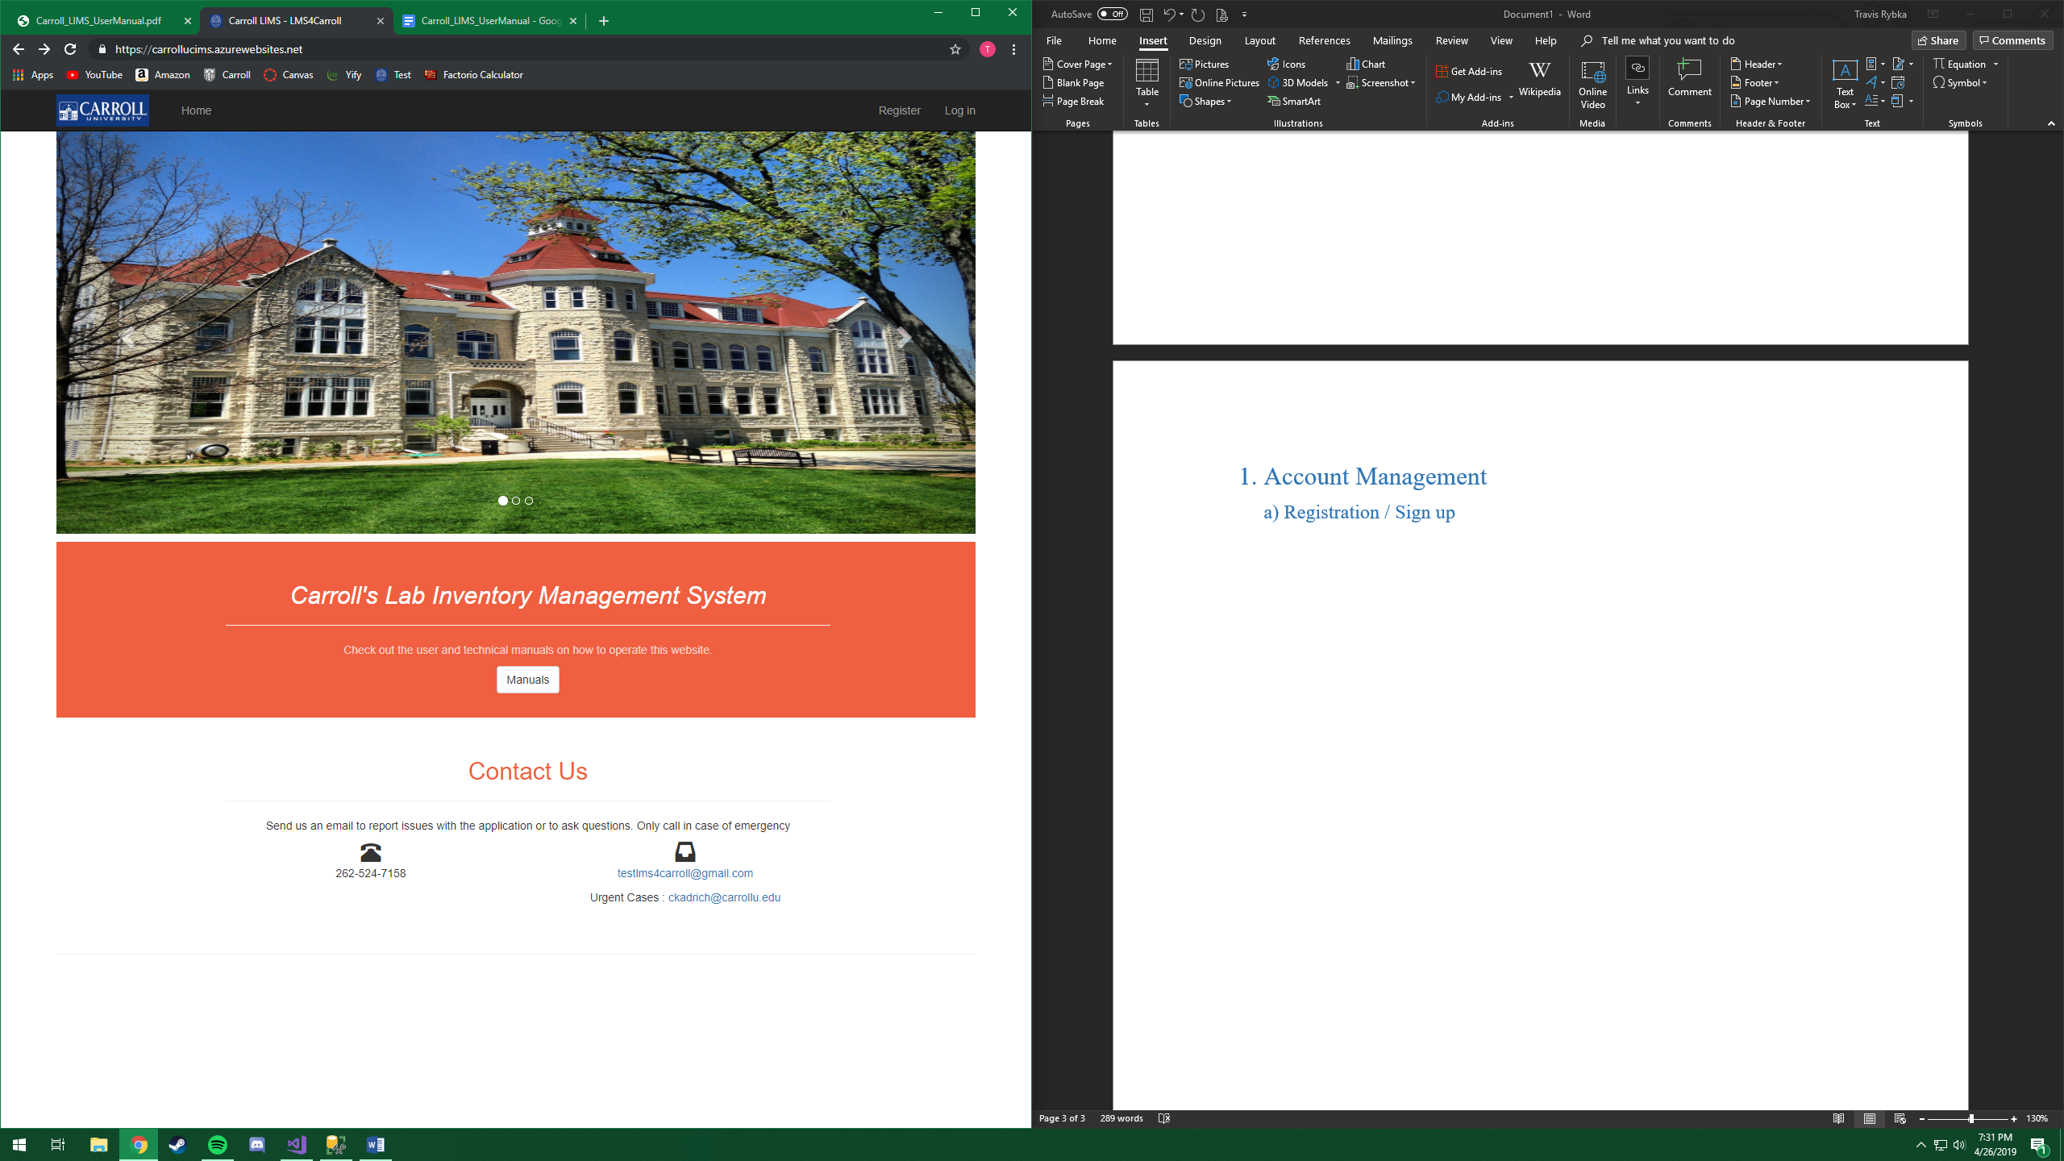

Click the registration button [marked by red arrow]

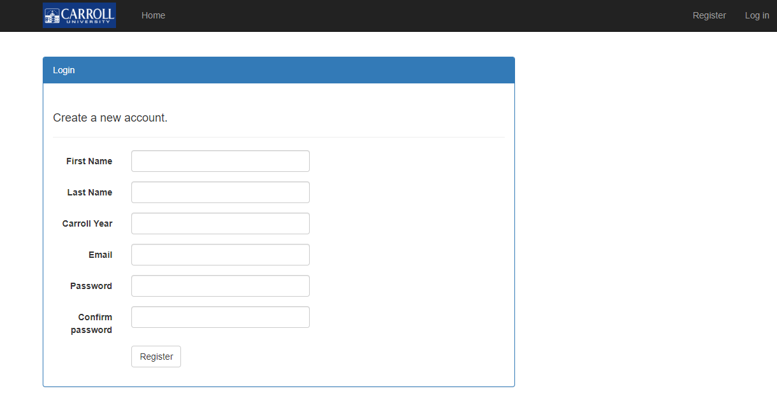

Account Requirements:

* First Name and Last Name have a minimum length of 3 characters with a maximum length of 50 characters.
* Carroll Year has minimum length of 3 characters and maximum length of 30 characters.
* Email (same as username) can have maximum length of 256 characters.
* The password should have minimum length of 6 characters, maximum length of 100 characters, and should have at least one symbol and one digit.

Once you register successfully, you will receive an email with account confirmation link in it. Your login will not be activated until the account confirmation link has been opened. Clicking on the link redirects you to a webpage confirming the activation.

b) Logging in

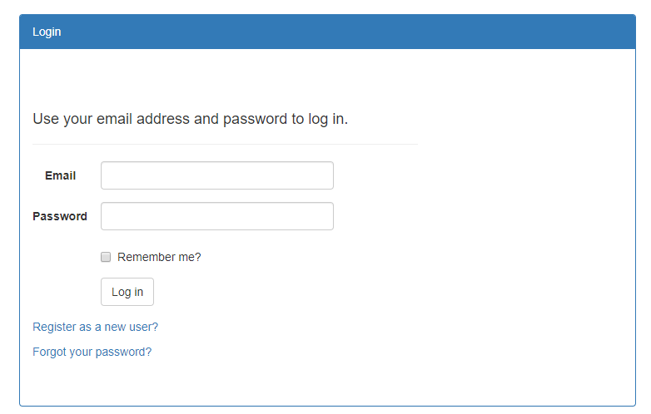

Type in your email address and your password, then click ‘Log in’ button.

c) Change Password

Click on your email address listed on the top right corner of menu bar.

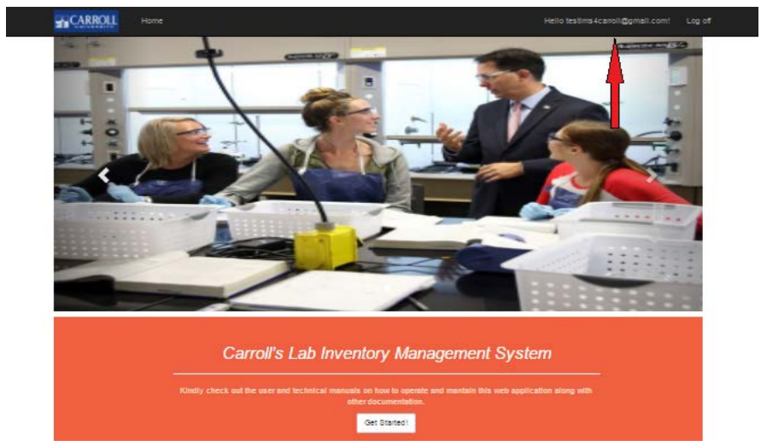

The following web page will appear. Click on ‘Change Password’ button.

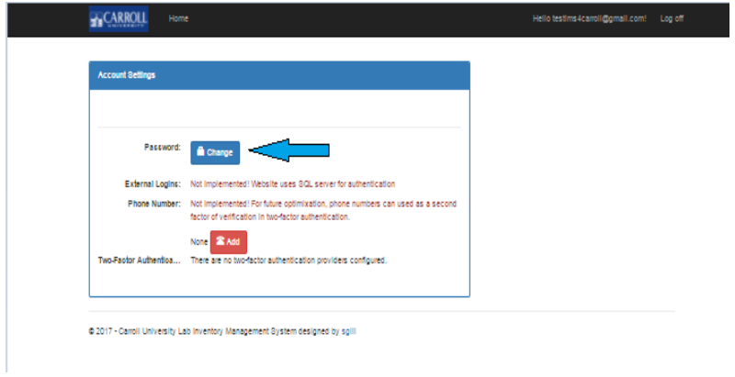

Type in your current password and your new password.

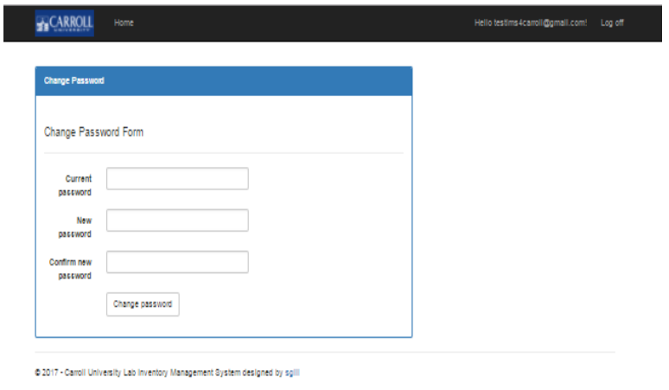

d) Forgot Password

If you forgot your password, it can be changed with email confirmation. On the Log in webpage, click on the forgot password link.

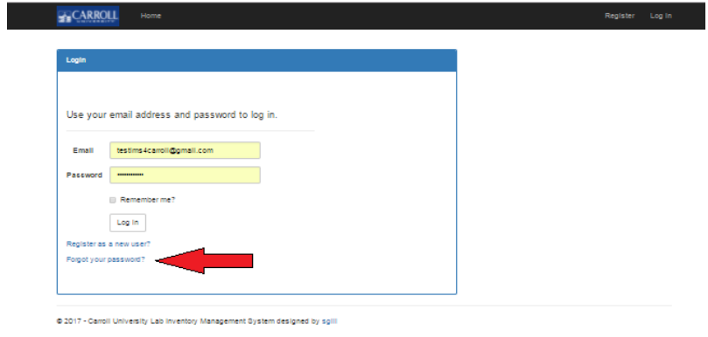

Then type in your email. Upon clicking “Submit”, you will receive an email that will allow you to reset your password.

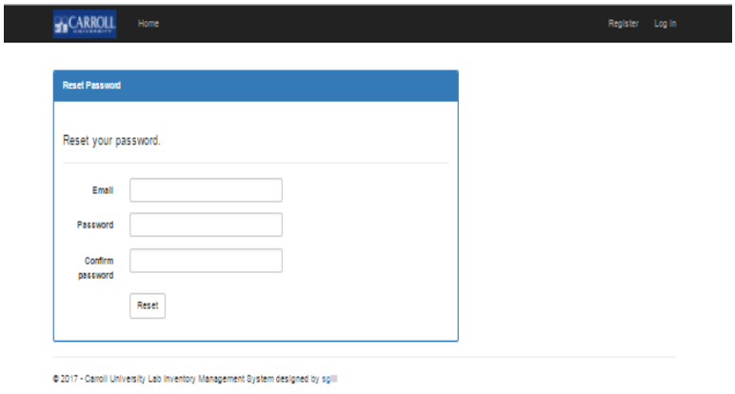

2. Admin Controls

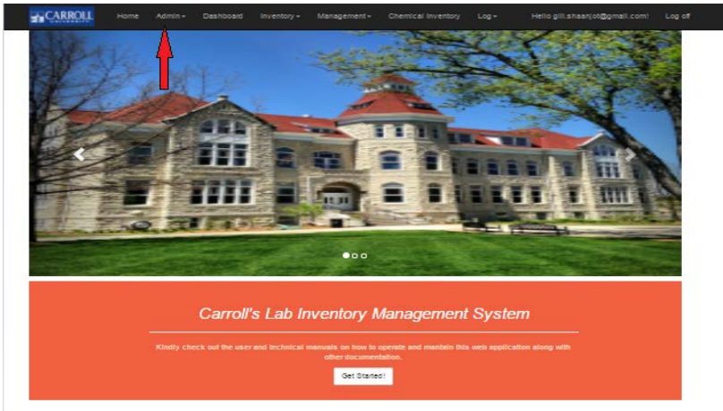

a) Add or Edit Users

You can change user properties such as First Name, Last Name, Email, and Application Role.

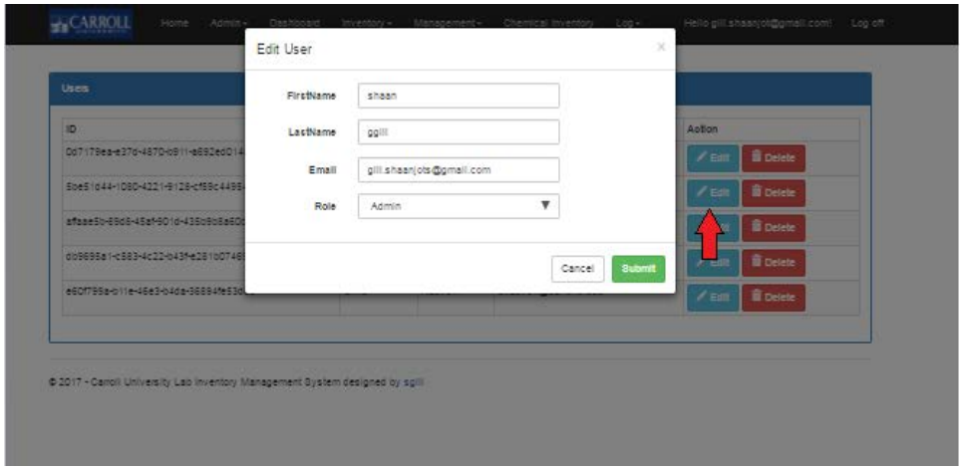

b) Delete Users

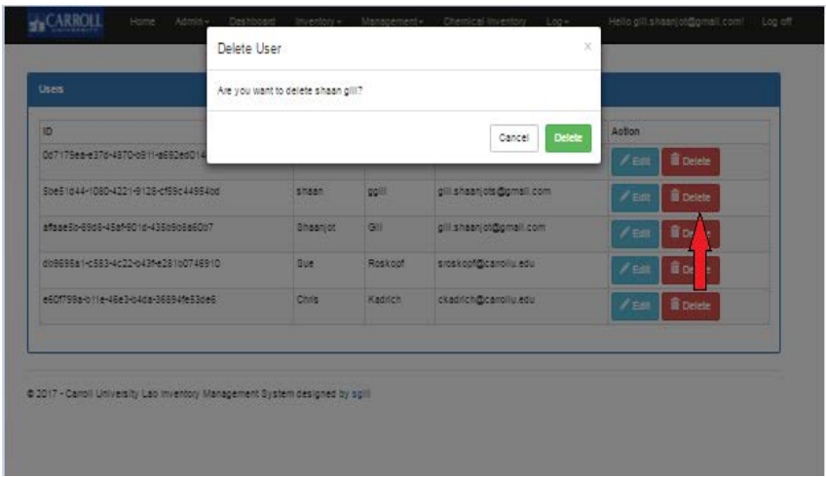

c) Add Application Role

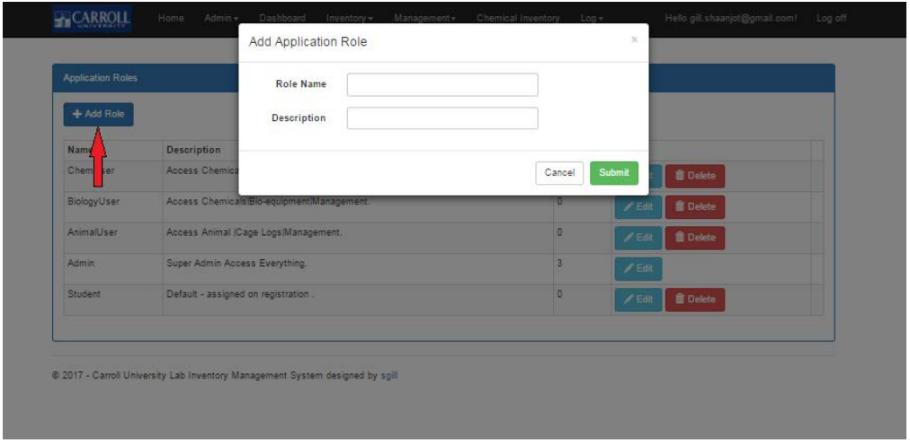

d) Edit User Application Role

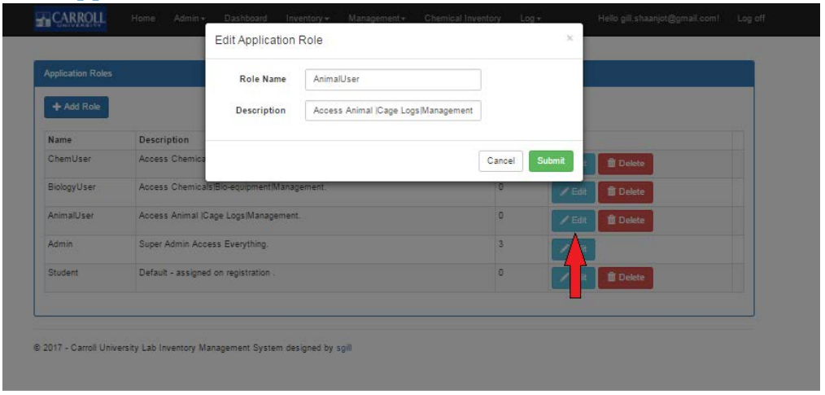

e) Delete Roles

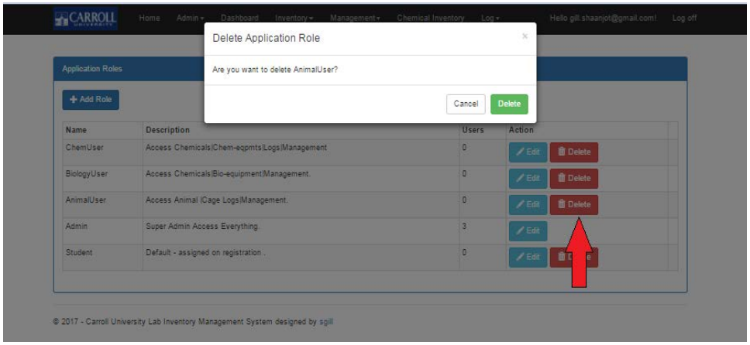

4. Data Tables

The following images will be from specific data tables, but the rules apply to all tables.

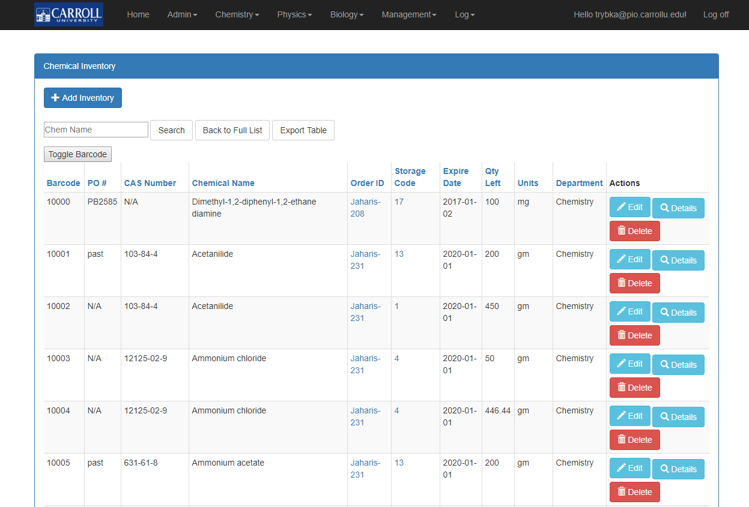

a) Add

Upon clicking the add button, you will be prompted to input all required information. Some data fields require specific formatting, which will prompt you if incorrect formatting is present.

b) Search

Tables have a search bar that allows users to search specific fields within the table. Note: most fields will work will partial matches, but not all. To clear the search, you may click “Back to Full List” or empty the search bar and click “Search”.

The headers on the tables are links that will allow you to sort the table based on that header. The first click will sort the table in ascending order, and the second click will put the table in descending order. This will also work while using the search function.

c) Export Table

By clicking this button, the table will download a file to the user’s browser in a .csv file format. This file can be opened in Microsoft Excel and allows for easy printing of the table.

d) Edit

This page is similar to adding a new entry. The webpage will have auto filled all the current data for the given entry. You can change what you wish and save your changes. Note: As in adding new entries, some data fields will have specific formatting.

e) Details

This webpage will show all data from a given entry on one page. For some tables, this may be more information that is in the table view.

f) Delete

Clicking this button will redirect to a confirmation page. This page will display the data fields on the given entry, so you may confirm you are deleting the correct entry. Note: THIS CANNOT BE UNDONE.

g) Make Log

This button is specific to the Chemical Formula table. The webpage allows users to record making a formula. Upon making a log, it will be available in the Log Formula table, which is only visible to Admins.